# Making Histograms

Referenced from lesson [Histograms](https://www.bootstrapworld.org/materials/spring2021/en-us/courses/data-science/lessons/histograms/index.shtml) (Spring, 2021)

Suppose we have a data set for a group of 50 adults, showing the number of teeth each person has:

| Number of teeth | Count |
| --- | --- |
| 0 | 5 |
| 22 | 1 |
| 26 | 1 |
| 27 | 1 |
| 28 | 4 |
| 29 | 3 |
| 30 | 5 |
| 31 | 3 |
| 32 | 27 |

**Draw a histogram for the table in the space below.** For each row, find which interval (or “bin”) on the x-axis represents the right number of teeth. Then fill in the box so that the height of the box is equal to the *sum of the counts* that fit into that interval. One of the intervals has been completed for you.

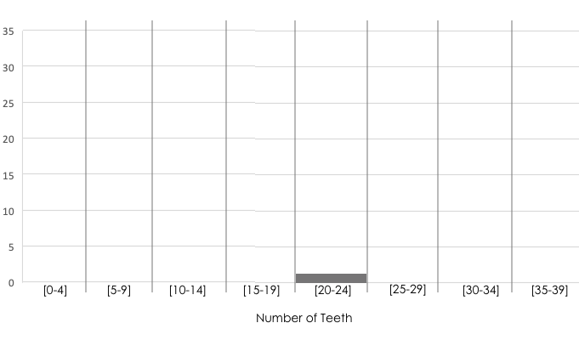

*These materials were developed partly through support of the National Science Foundation, (awards 1042210, 1535276, 1648684, and 1738598).  Bootstrap:Data Science by the* [*Bootstrap Community*](https://bootstrapworld.org/community/index.shtml) *is licensed under a* [*Creative Commons 4.0 Unported License*](https://creativecommons.org/licenses/by-nc-nd/4.0/)*. This license does not grant permission to run training or professional development. Offering training or professional development with materials substantially derived from Bootstrap must be approved in writing by a Bootstrap Director. Permissions beyond the scope of this license, such as to run training, may be available by contacting* [*contact@BootstrapWorld.org*](https://www.bootstrapworld.org/materials/spring2021/en-us/courses/data-science/lessons/histograms/pages/mailto:contact@BootstrapWorld.org)*.*

Last updated 2021-12-08 12:31:27 -0500